

**ISY994 Series – OpenADR 2.0(a)/(b)**

**EPRI VTN Configuration Guide**

**Courtesy of Jim Zuber at QualityLogic**

*Requires firmware 4.1.3+

1. From the EPRI VTN, create a new VEN with the following configuration settings:

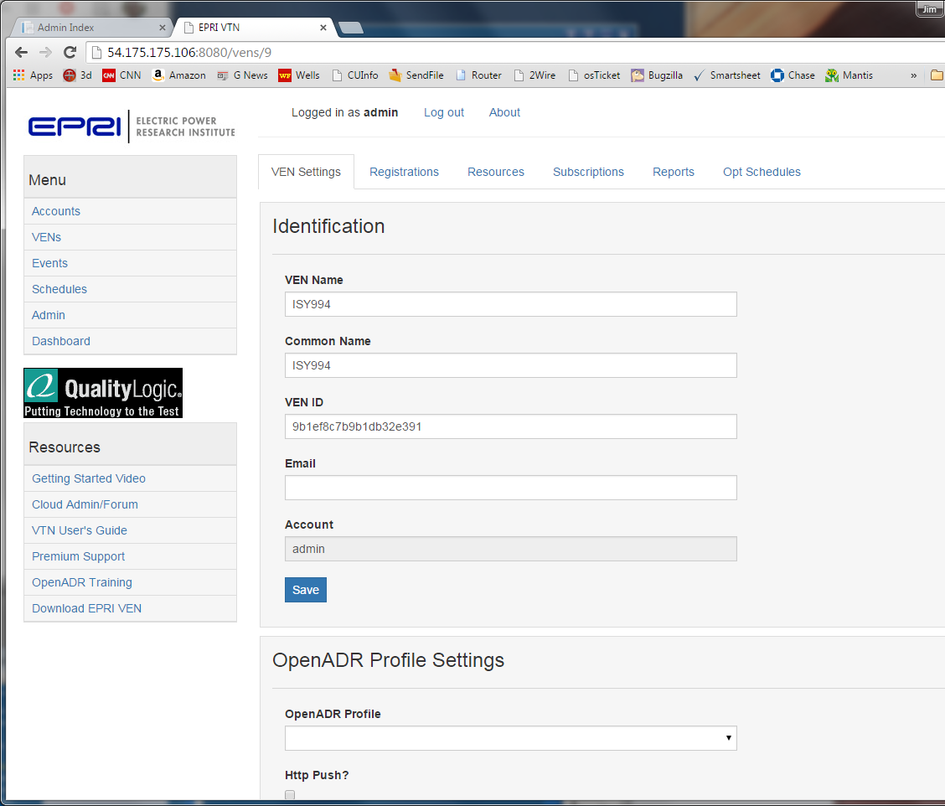

2. Subscribe to marketContext1 as show below:

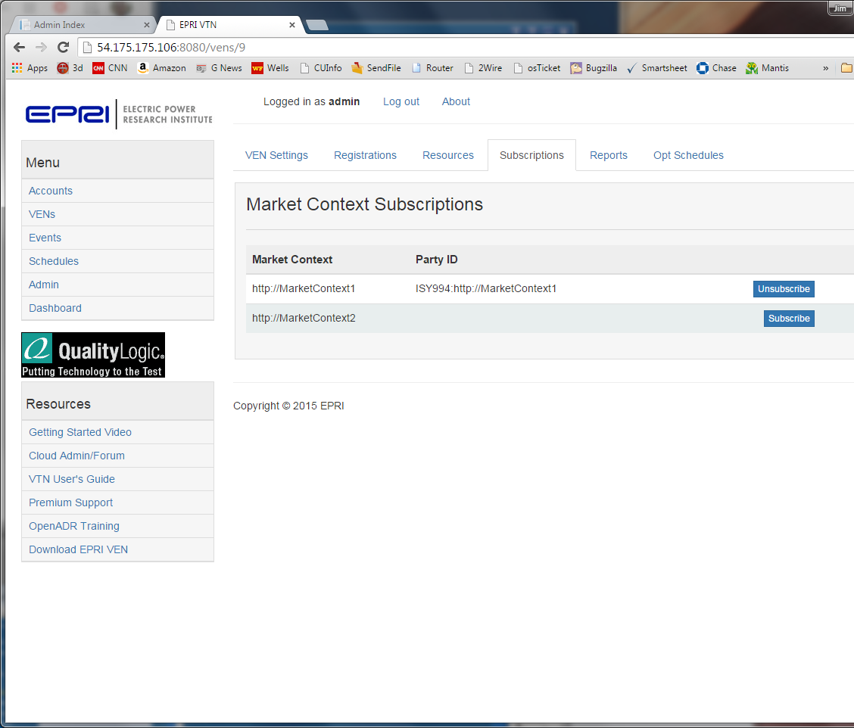

3. Configure ISY settings as follows using your IP address of you EPRI VTN.

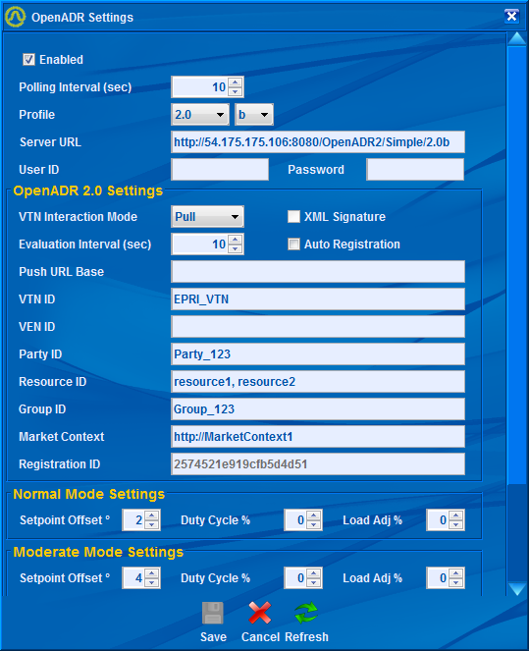

4. From the ISY Registration dialog, make sure it is configured as show below, then click on the register button at the bottom. You should see the registration ID change from N/A to a hex number.

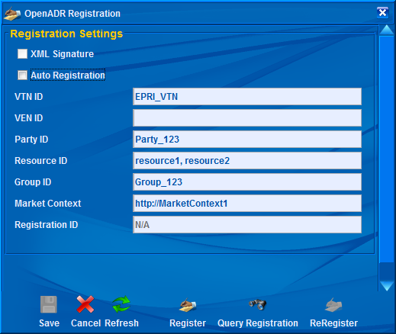

5. To create an event, select the Events tab at the left side of the screen, the click the Create Event Button and you will see the following dialog. Check the following fields in the dialog as shown below: Duration, Signal Type Payload. Then click the green Create Event button.

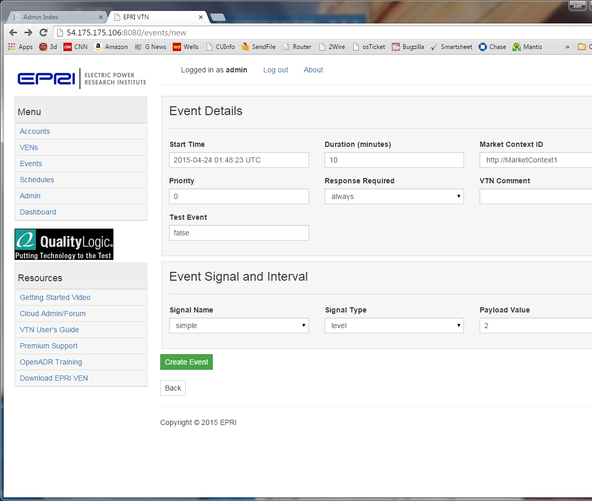

6. Click on the target tab, then the VENs sub tab. Select ISY994 from the drop down and click add as show below

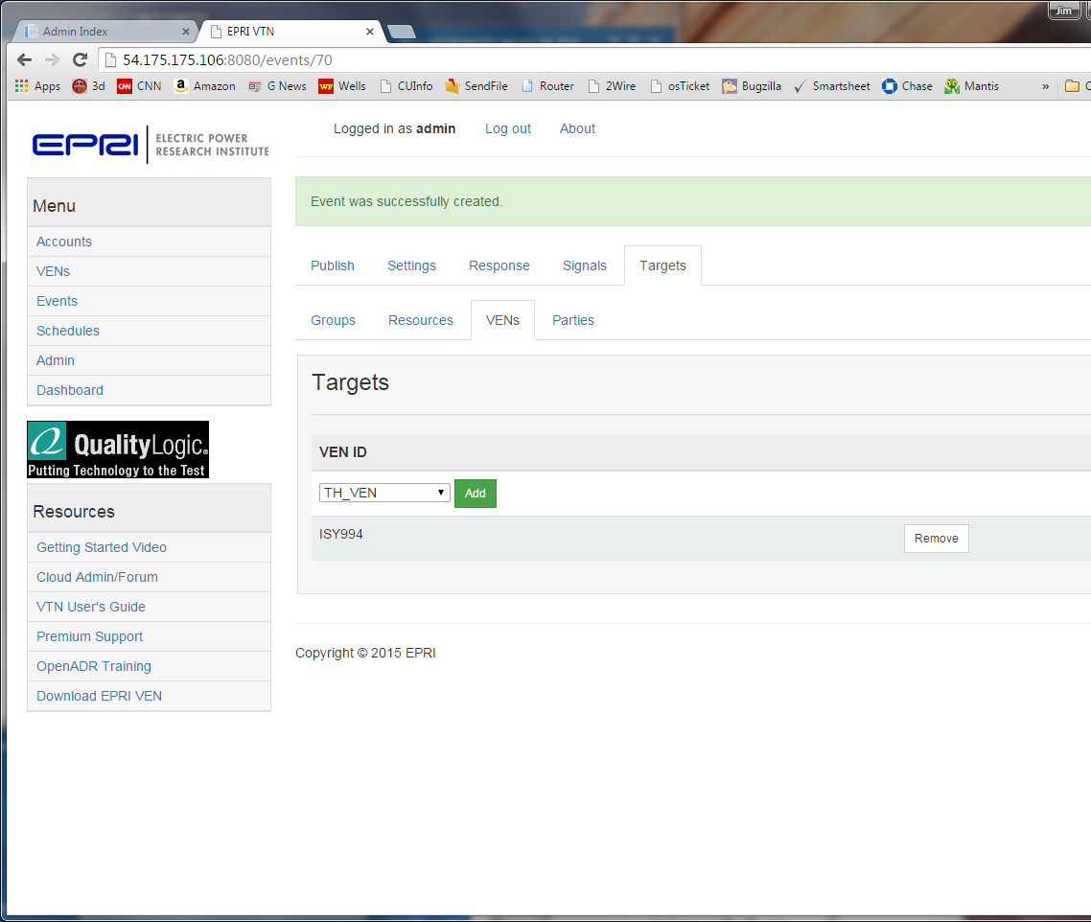

7. Click on the publish tab and click the green Publish Event button as show below. Your event will now be available to be pick up by the VENs next polling interval.

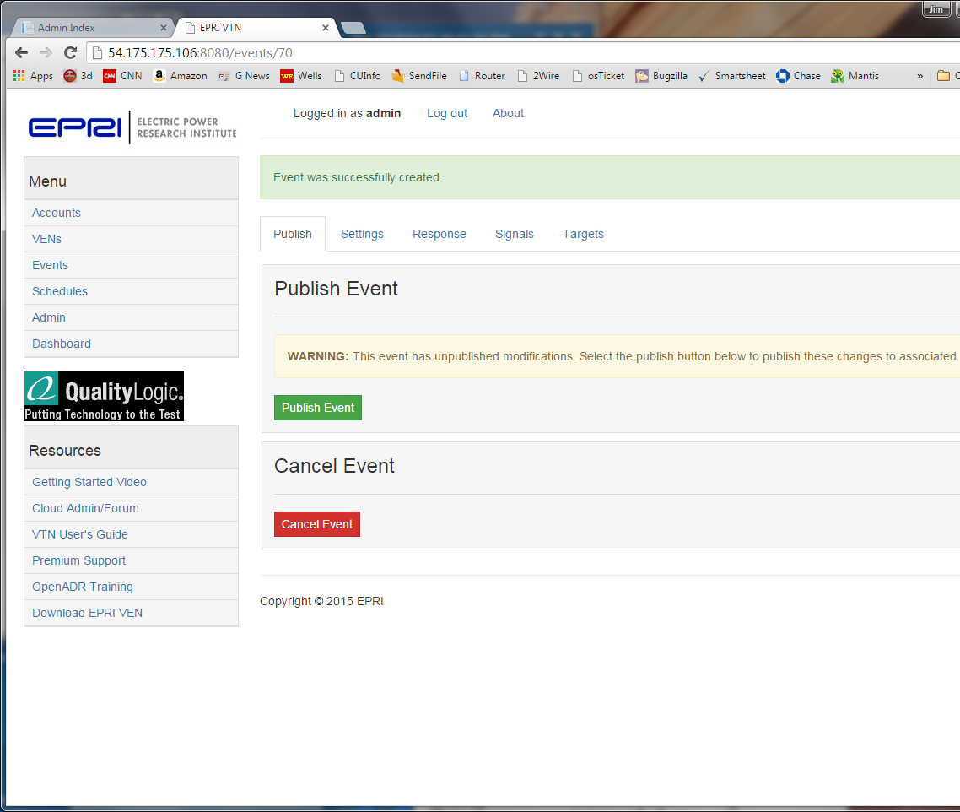

At the next polling interval you will see the event in ISY as show below:

