ISY994zw Series Quick Setup Guide

This product is a security enabled Z-Wave product that is able to use encrypted Z-Wave messages to communicate with other security enabled Z-Wave products.

This product can be included and operated in any Z-Wave network with other Z-Wave certified devices from any other manufacturers. All constantly powered nodes in the same network will act as repeaters regardless of the vendor in order to increase reliability of the network.

ISY Installation

- Connect one of the included Cat5e cable to ISY’s Network Port and to your network hub.

Note: the network must initially be DHCP enabled. If DHCP is not enabled, please configure ISY with a static IP address the instructions for which you will find here.

Host Computer Configuration

- If you do not have Java installed, please install the latest for your platform. You may find the latest Java downloads at http://www.java.com/getjava. Please choose the latest JRE for your platform

- Start a Web Browser of your choice and go to http://isy.universal-devices.com/994 ; when prompted to authenticate, enter admin for both user-id and password

- If you would like to access your ISY without a browser, please go to http://isy.universal-devices.com/994/admin.jnlp

- On Universal Devices Administrative Console, choose Help | About (Figure 2)

- On the About Dialog, locate My URL and write down the URL. For example, in Figure 2B, the URL is http://192.168.0.101. You may also access your ISY using this URL (as long as your router does not change the address for ISY)
Note: If you have Windows XP, Vista, or Windows 7 and if you have UPnP (XP)/Device Discovery (Vista) enabled on your computer, you will see an ISY icon appear in My Network Places (XP) or Network (Vista/Windows 7). (Figure 2A)

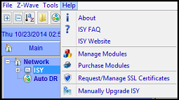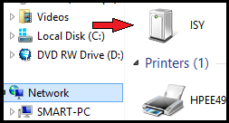
Figure 2 Figure 2A

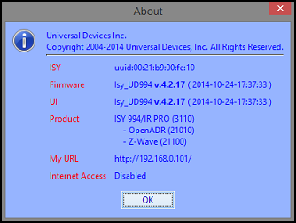
Figure 2B

Final Steps

Set Time and Location

Click on the Configuration | System tab and set the Time and the Physical Location for the unit (used for Sunrise/Sunset calculations). See Figure 3A. 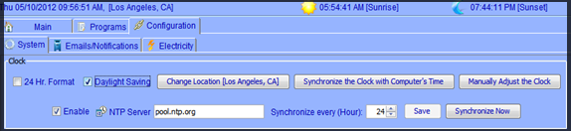Figure 3A

Start Adding Your Z-Wave Devices!

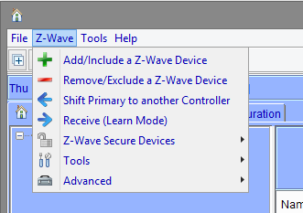
Figure 3B

See the ISY-994 Series Z-Wave Module Guide for full instructions
http://www.universal-devices.com/docs/production/zw.doc

Create some Programs

After you have added some Z-Wave devices, and if so desired, you can create programs to automatically control your devices, send notifications, and do many other things. Click on the Programs | Details tab and you will see a sample Query All program. Below that there is an option to “Add Program” Click on that. The example for this program will be to turn On the Porch Light at 7pm and off 4 hours later. See Figure 3C.

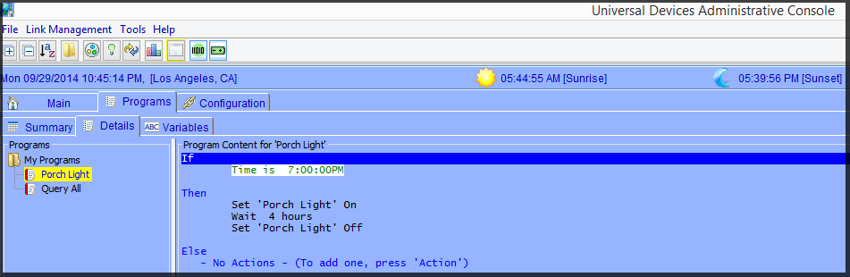 Figure 3C

For additional documentation, please visit http://wiki.universal-devices.com
For our Product and Technical Support Page please visit:
https://www.universal-devices.com/udi-support
Don’t forget to register your unit to receive important enhancements, updates and upgrade information: http://www.universal-devices.com/register
ENJOY!

